**Rohan Nyati**

**500075940**

**R177219148**

**Batch-5 (Ai & Ml)**

**Class Test 1**

**Q.1** Discuss the Cloud Computing Architecture in detail with the help of example and diagram.

Cloud computing architecture is a combination of **service-oriented architecture** and **event-driven architecture**.

Cloud computing architecture is divided into the following two parts -

* Front End
* Back End

The below diagram shows the architecture of cloud computing -

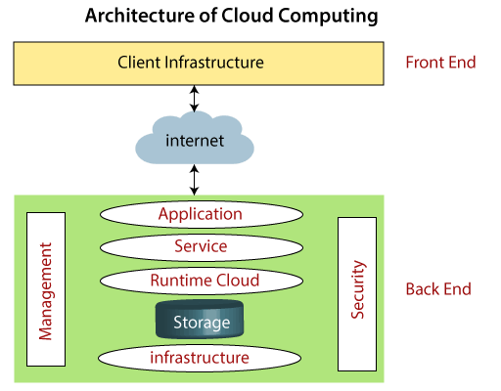

Front End

The front end is used by the client. It contains client-side interfaces and applications that are required to access the cloud computing platforms. The front end includes web servers (including Chrome, Firefox, internet explorer, etc.), thin & fat clients, tablets, and mobile devices.

Back End

The back end is used by the service provider. It manages all the resources that are required to provide cloud computing services. It includes a huge amount of data storage, security mechanism, virtual machines, deploying models, servers, traffic control mechanisms, etc.

**Question 2:**Discuss the advantages and disadvantages of Cloud Computing.

## **Advantages of Cloud Computing**

As we all know that Cloud computing is trending technology. Almost every company switched their services on the cloud to rise the company growth.

Here, we are going to discuss some important advantages of Cloud Computing-

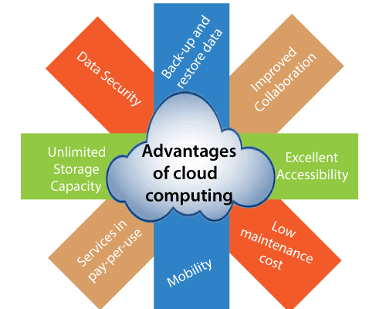

### 1) Back-up and restore data

Once the data is stored in the cloud, it is easier to get back-up and restore that data using the cloud.

### 2) Improved collaboration

Cloud applications improve collaboration by allowing groups of people to quickly and easily share information in the cloud via shared storage.

### 3) Excellent accessibility

Cloud allows us to quickly and easily access store information anywhere, anytime in the whole world, using an internet connection. An internet cloud infrastructure increases organization productivity and efficiency by ensuring that our data is always accessible.

### 4) Low maintenance cost

Cloud computing reduces both hardware and software maintenance costs for organizations.

### 5) Mobility

Cloud computing allows us to easily access all cloud data via mobile.

### 6) IServices in the pay-per-use model

Cloud computing offers Application Programming Interfaces (APIs) to the users for access services on the cloud and pays the charges as per the usage of service.

### 7) Unlimited storage capacity

Cloud offers us a huge amount of storing capacity for storing our important data such as documents, images, audio, video, etc. in one place.

### 8) Data security

Data security is one of the biggest advantages of cloud computing. Cloud offers many advanced features related to security and ensures that data is securely stored and handled.

## **Disadvantages of Cloud Computing**

A list of the disadvantage of cloud computing is given below -

### 1) Internet Connectivity

As you know, in cloud computing, every data (image, audio, video, etc.) is stored on the cloud, and we access these data through the cloud by using the internet connection. If you do not have good internet connectivity, you cannot access these data. However, we have no any other way to access data from the cloud.

### 2) Vendor lock-in

Vendor lock-in is the biggest disadvantage of cloud computing. Organizations may face problems when transferring their services from one vendor to another. As different vendors provide different platforms, that can cause difficulty moving from one cloud to another.

### 3) Limited Control

As we know, cloud infrastructure is completely owned, managed, and monitored by the service provider, so the cloud users have less control over the function and execution of services within a cloud infrastructure.

### 4) Security

Although cloud service providers implement the best security standards to store important information. But, before adopting cloud technology, you should be aware that you will be sending all your organization's sensitive information to a third party, i.e., a cloud computing service provider. While sending the data on the cloud, there may be a chance that your organization's information is hacked by Hackers.